\
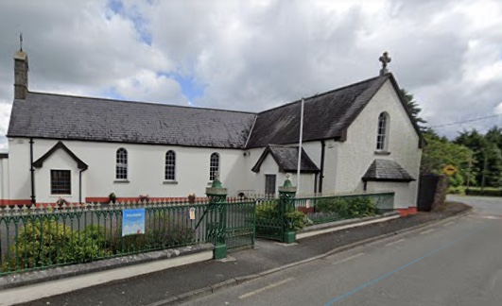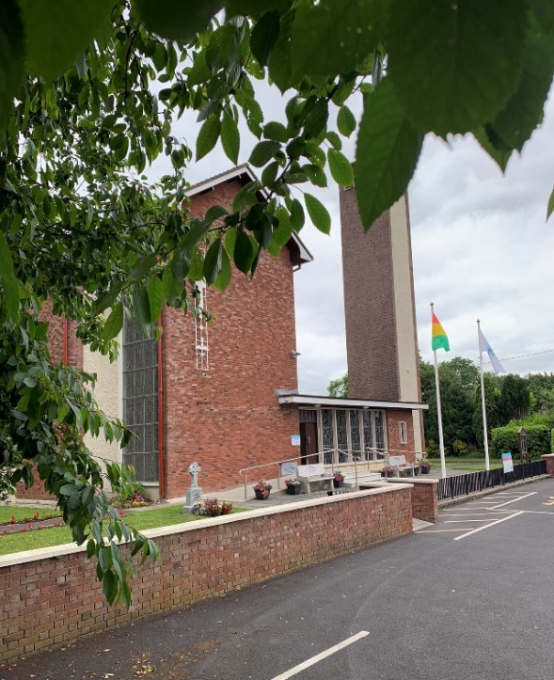 |  | Parish Newsletter Cooleragh-Staplestown  - 2nd -3rd July ‘22
^{14th} Sunday in ordinary time |  | Please take one home with you

Office Hours & Mass Times

Office Hours 9.30am -12 noon, Tue Thur & Fri Office closed Wednesday. Email; standco100@gmail.com. Office landline 045 860281 website; www.cooleraghstaplestownparish.com Webcam; http://www.mcnmedia.tv/camera/christ-the-king-church-cooleragh Newsletter deadline Wednesday 11.59pm. Parish Priest; Fr. John
Anniversaries this Weekend 6.30pm; Larry Higgins Clane, Rosie Brosnan Blackwood, Mary Cronly Coill Dubh.Fr. Eamonn Mulvihill PP
8.30am Patricia Melia Blackwood, Mary Cronly Coill Dubh. Fr. Eamonn Mulvihill PP.
11.15am; Alice Kelly Staplestown and her husband Johnny.
Next Week’s Anniversaries: 6.30pm: John O’Leary Coill Dubh 11.15am Christopher & Martha Cummins Corkeragh, Thomas Reilly 100th anniversary
The death has occurred of Michael Dolan late of the Stores Corduff son of John & Kathleen Dolan
Summer Collection Envelope are available at the back of the churches for the summer collection for the support of the clergy. Monies given go into a fund out of which our clergy receives their income. Thank you as always for your generosity & support.
Ministers of the Word & Eucharist for next week 9th -10th July ‘22
Christ the King Cooleragh
6.30pm Michael Mc Cormack
8.30am Blathnaid Tennyso
St Benignus Staplestown
11.15am Domnic Cogan.

Christ the King Cooleragh
6.30pm Mary Cosgrove
8.30am Catherine Harney

St Benignus Staplestown 11. 15am Janet Colgan & Bernie Marron
Matt Talbot, Freedom from Addiction Mass
The next Matt Talbot, Freedom from addiction Mass takes place on Monday 4th July at 10:00am in Carlow Cathedral. We welcome you to join us at this Mass to pray for all those battling addiction, their families and all those affected by addiction. We pray specifically at this Mass for all those enrolled in the Matt Talbot Prayer Society. If you wish to enroll somebody in the Matt Talbot Prayer Society, please call 028 71262894.
Envelope & Offertory Collections Parish Envelopes Total €509 Offertory Collection €625
As always, we thank you most sincerely for your kind generosity to our parish & our Priest
Cooleragh Parish Acc No 1: IIBAN IE43 AIBK 9332 3629 5300 19

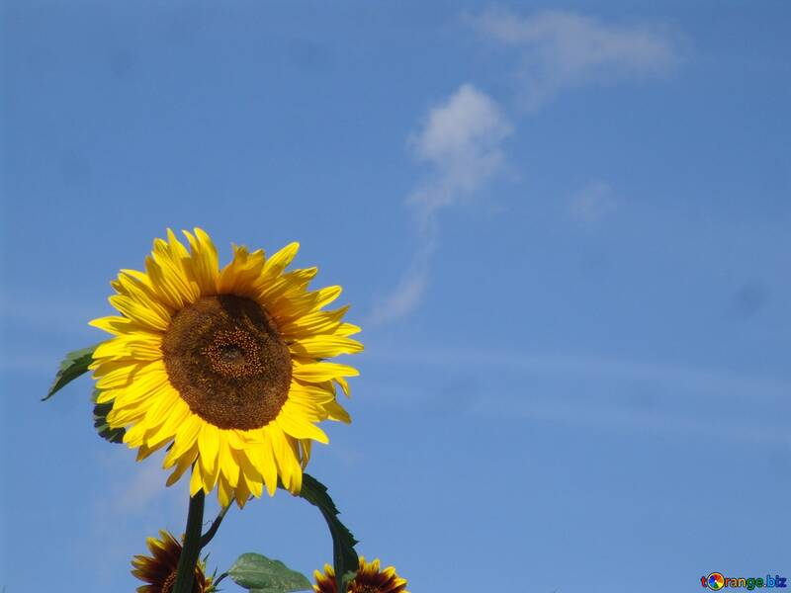
Keep the Date: Cemetery Sunday next year in this Parish will be the 3rd Sunday in June which is 18th June 2023
A Summer Prayer
Father, Creator for all,
thank, you for the summer
Thank you for the warmth of the sun and the increase of daylight, Thank, you for the beauty I see all around me and for the opportunity to be outside and enjoy your creation.
Thank you for the increased time I have to be with family and friends, and for the causal pace of the summer season.

Draw me closer to you this summer.
Teach me how I can pray no matter where I am or what I am doing.
Warm my soul with the awareness of your presence and light my path with your Word and Counsel.
As I enjoy your creation, create in me a pure heart and a hunger and thirst for you. Amen.
Author Unknown

